ABSTRACT

Creating a user-friendly and efficient doctor appointment dashboard using HTML is the focus of this abstract. In the rapidly evolving landscape of web development, HTML remains a fundamental tool for crafting intuitive interfaces. This abstract outline the key components and considerations involved in building a doctor appointment dashboard using HTML, highlighting the importance of user-centric design and seamless functionality.

The proposed doctor appointment dashboard leverages the

versatility of HTML to offer medical practitioners and patients an accessible

platform for scheduling appointments and managing healthcare interactions. The

interface is designed with a user-centric approach, ensuring ease of navigation

and a clear hierarchy of information. HTML's markup capabilities are utilized

to structure the dashboard's layout, enabling the integration of various

elements such as appointment forms, patient profiles, and appointment history.

The dashboard's interface is carefully crafted to accommodate

both medical practitioners and patients. Medical practitioners are provided

with tools to manage their schedules, mark their availability, and access

patient profiles efficiently. HTML's form elements enable the creation of

appointment forms that gather essential patient information, enhancing the

accuracy of healthcare records.

For patients, the dashboard offers a straightforward process to

browse available appointments, select preferred doctors, and schedule visits.

The responsive design principles of HTML ensure that the dashboard is

accessible on various devices, including desktops, tablets, and smartphones,

thereby enhancing user engagement and convenience.

A fundamental aspect of the dashboard's functionality is its

interactivity. HTML's scripting capabilities, particularly when paired with

JavaScript, facilitate the implementation of real-time features such as

appointment date and time selection, dynamic availability updates, and instant

error validation. Additionally, HTML's integration with CSS allows for the

customization of the dashboard's appearance, fostering a cohesive and visually

appealing user experience.

OBJECTIVE

The objective of this project is to design and create a user-friendly doctor appointment dashboard using HTML, with a focus on providing healthcare practitioners and patients a seamless platform for managing appointments, enhancing communication, and streamlining healthcare interactions. The primary goals of this project are as follows:

* **User-Centric Design:** Craft an intuitive and visually appealing dashboard interface that caters to the needs of both medical practitioners and patients. Ensure a clear and organized layout that facilitates easy navigation and accessibility, promoting a positive user experience.
* **Efficient Appointment Management:** Implement HTML forms to enable medical practitioners to manage their schedules, mark availability, and update appointment slots in real-time. Develop an appointment booking system that allows patients to select preferred doctors, browse available time slots, and schedule appointments conveniently.
* **Comprehensive Patient Profiles:** Utilize HTML forms to collect and display essential patient information, contributing to accurate medical records. Ensure that patient profiles are easily accessible to practitioners for personalized care and treatment planning.
* **Real-Time Interactivity:** Employ HTML's scripting capabilities, in conjunction with JavaScript, to provide dynamic features such as real-time availability updates, interactive appointment calendars, and instant error validation for appointment scheduling.
* **Responsive Design:** Apply responsive web design principles using HTML and CSS to ensure the doctor appointment dashboard functions seamlessly across various devices, including desktops, tablets, and smartphones. Prioritize a consistent and user-friendly experience regardless of screen size.
* **Enhanced Communication:** Integrate HTML-based communication tools that allow practitioners to send appointment confirmations, reminders, and follow-up instructions to patients. Foster improved doctor-patient communication and engagement through the dashboard.
* **Data Privacy and Security:** Implement security measures to safeguard patient data and ensure compliance with privacy regulations. Employ HTML techniques for secure data transmission and storage to maintain patient confidentiality.
* **Customizability:** Utilize HTML and CSS to offer customization options for the dashboard's appearance, enabling healthcare institutions to align the dashboard's visual identity with their branding.
* **Testing and Iteration:** Conduct thorough testing of the dashboard's functionality, usability, and responsiveness across different devices and browsers. Incorporate user feedback to identify areas of improvement and iterate on the design and features.
* **Documentation and Training:** Provide comprehensive documentation outlining the dashboard's features, functionalities, and maintenance procedures. Offer training materials to assist medical practitioners and administrative staff in effectively using and managing the dashboard.

By achieving these objectives, the project aims to create a robust doctor appointment dashboard using HTML that optimizes appointment management, strengthens doctor-patient relationships, and contributes to a more efficient and patient-centered healthcare system.

INTRODUCTION

In the era of digital transformation, healthcare services are increasingly leveraging technology to streamline processes and improve patient care. The creation of a doctor appointment dashboard using a combination of HTML, CSS, and PHP presents an innovative solution that enhances appointment management, patient engagement, and administrative efficiency. This dashboard harnesses the power of web technologies and server-side scripting to establish a dynamic platform that connects medical practitioners and patients in a seamless and user-centric manner.

The doctor appointment dashboard serves as a bridge between healthcare providers and patients, offering an intuitive and accessible interface for scheduling appointments, accessing medical information, and facilitating effective communication. By utilizing HTML for structural layout, CSS for visual design, and PHP for backend logic, this project aims to construct a comprehensive dashboard that caters to the unique needs of both healthcare professionals and patients.

The primary objective of this project is to design and implement a sophisticated dashboard that empowers medical practitioners to manage their schedules efficiently and enables patients to actively participate in their healthcare management. HTML's markup capabilities will structure the dashboard's layout, CSS will provide a consistent and appealing visual experience, and PHP's server-side scripting will facilitate secure data processing and real-time interactions.

This paper will delve into the fundamental principles, functionalities, and synergies of HTML, CSS, and PHP in the creation of a doctor appointment dashboard. By exploring key elements such as user authentication, appointment scheduling systems, database integration, and responsive design, we will illustrate how this trio of technologies collaborates to offer a versatile and effective solution for modern healthcare appointment management.

Through this project, we seek to underscore the importance of seamlessly integrating HTML, CSS, and PHP to develop a robust doctor appointment dashboard. This solution holds the potential to elevate healthcare efficiency, empower patients to actively engage in their care, and simplify the complex administrative tasks associated with healthcare services. By recognizing the collective power of these technologies, we lay the foundation for a transformative approach to healthcare delivery and management.

Code(HTML)

<!DOCTYPE html>

<html lang="en">

<head>

<meta charset="UTF-8">

<meta http-equiv="X-UA-Compatible" content="IE=edge">

<meta name="viewport" content="width=device-width, initial-scale=1.0">

<title>Doctors Appointment | Arupa</title>

<link rel="stylesheet" href="doctor.css" type="text/css">

<link href="https://cdn.jsdelivr.net/npm/bootstrap@5.0.2/dist/css/bootstrap.min.css" rel="stylesheet"

integrity="sha384-EVSTQN3/azprG1Anm3QDgpJLIm9Nao0Yz1ztcQTwFspd3yD65VohhpuuCOmLASjC" crossorigin="anonymous">

<script src="https://cdn.jsdelivr.net/npm/bootstrap@5.0.2/dist/js/bootstrap.bundle.min.js"

integrity="sha384-MrcW6ZMFYlzcLA8Nl+NtUVF0sA7MsXsP1UyJoMp4YLEuNSfAP+JcXn/tWtIaxVXM" crossorigin="anonymous"></script>

</head>

<body>

<div class="writeenText">

<p class="h4 text-uppercase text-decoration-underline">

Appoint yourself here for your health and for a good treatment

</p>

<p><b>Schedule the Appointment</b> Contact the doctor's office or clinic to schedule an appointment. Be sure to provide them with your availability and any specific concerns you have.

<br>

<b>Choose the Right Doctor</b>: If you're seeing a new doctor, make sure they are a good fit for your needs. Consider their specialty, experience, and any reviews or recommendations from others.

<br>

<b>Prepare Information</b> Before the appointment, gather important information. This includes your medical history, any current medications, allergies, and any symptoms you're experiencing. Write down any questions you have so you don't forget during the appointment.

<br>

<b>Arrive Early</b> Plan to arrive a little early for your appointment. This allows time for any necessary paperwork or updates to your information.

<br>

<b> Necessary Documents</b> Bring your identification, insurance card, and any relevant medical records, if applicable.

</p>

</div>

<div class="docImage">

<img src="image/doctor.avif" width="100%" height="100%" class="doctImage">

</div>

<div class="appointBox">

<form action="doctor.php" method="POST">

<div class="appHead">

<p>Doctor Appointment</p>

</div>

<div class="form-data">

<div class="row form-row">

<input type="text" name="firstName" id="firstName" class="firstName form-control" placeholder="First Name" required>

</div>

<div class="row form-row">

<input type="text" name="lastName" id="lastName" class="lastName form-control" placeholder="Last Name" required>

</div>

<div class="row form-row">

<input type="text" name="phNumber" id="phNumber" class="phNumber form-control" placeholder="Phone Number" required>

</div>

<div class="row form-row">

<input type="email" name="email" id="email" class="email form-control" placeholder="Email" required>

</div>

<p>Address details</p>

<div class="row form-row">

<div class="col-md-6">

<input type="text" name="pinCode" id="pinCode" class="pinCode form-control" placeholder="Pin Code" required>

</div>

<div class="col-md-6">

<input type="text" name="location" id="location" class="location form-control" placeholder="Location / Area /Streat" required>

</div>

</div>

<div class="row form-row" >

<div class="col-md-6">

<input type="text" name="city" id="city" class="city form-control" placeholder="District / City" required>

</div>

<div class="col-md-6">

<select name="state" id="inputState" class="form-select form-control">

<option selected disabled>State</option>

<option value="Andhra Pradesh">Andhra Pradesh</option>

<option value="Andaman and Nicobar Islands">Andaman and Nicobar Islands</option>

<option value="Arunachal Pradesh">Arunachal Pradesh</option>

<option value="Assam">Assam</option>

<option value="Bihar">Bihar</option>

<option value="Chandigarh">Chandigarh</option>

<option value="Chhattisgarh">Chhattisgarh</option>

<option value="Dadar and Nagar Haveli">Dadar and Nagar Haveli</option>

<option value="Daman and Diu">Daman and Diu</option>

<option value="Delhi">Delhi</option>

<option value="Lakshadweep">Lakshadweep</option>

<option value="Puducherry">Puducherry</option>

<option value="Goa">Goa</option>

<option value="Gujarat">Gujarat</option>

<option value="Haryana">Haryana</option>

<option value="Himachal Pradesh">Himachal Pradesh</option>

<option value="Jammu and Kashmir">Jammu and Kashmir</option>

<option value="Jharkhand">Jharkhand</option>

<option value="Karnataka">Karnataka</option>

<option value="Kerala">Kerala</option>

<option value="Madhya Pradesh">Madhya Pradesh</option>

<option value="Maharashtra">Maharashtra</option>

<option value="Manipur">Manipur</option>

<option value="Meghalaya">Meghalaya</option>

<option value="Mizoram">Mizoram</option>

<option value="Nagaland">Nagaland</option>

<option value="Odisha">Odisha</option>

<option value="Punjab">Punjab</option>

<option value="Rajasthan">Rajasthan</option>

<option value="Sikkim">Sikkim</option>

<option value="Tamil Nadu">Tamil Nadu</option>

<option value="Telangana">Telangana</option>

<option value="Tripura">Tripura</option>

<option value="Uttar Pradesh">Uttar Pradesh</option>

<option value="Uttarakhand">Uttarakhand</option>

<option value="West Bengal">West Bengal</option>

</select>

</div>

</div>

<p>Address Type</p>

<div class="col-md-6 radio-app">

<input type="radio" name="typeAddq" id="typeAdd" class="typeAdd" value="home">

<label for="typeAdd">Home</label>

<input type="radio" name="typeAddq" id="typeAdd1" class="typeAdd" value="work">

<label for="typeAdd1">Work</label>

<input type="radio" name="typeAddq" id="typeAdd2" class="typeAdd" value="other">

<label for="typeAdd2">Other</label>

</div>

<div class="row form-row">

<button type="submit" class="appButton btn btn-success" name="submit">Book Appointment</button>

</div>

</div>

</form>

</div>

</body>

CODE(CSS)

*

{

margin: 0px;

padding: 0px;

box-sizing: border-box;

font-family: 'Lucida Sans', 'Lucida Sans Regular', 'Lucida Grande', 'Lucida Sans Unicode', Geneva, Verdana, sans-serifs;

}

body

{

min-height: 100vh;/*viewport height*/

background: linear-gradient(rgb(48, 42, 94),rgb(255, 255, 255));/* we can use it for further updates in the style*/

width: 100%;

height: 100%;

}

.docImage{

position: absolute;

z-index: -1px;

}

.writeenText{

z-index: 20px;

position: absolute;

color: black;

top: 200px;

left:100px;

width: 500px;

height: auto;

}

.doctImage{

opacity: 40%;

}

.appointBox{

position: relative;

top: 140px;

left: 840px;

border: 1px solid transparent;

background-color: rgb(241, 231, 219);

width: 450px;

z-index: 200000;

}

.form-data{

padding: 10px;

}

.form-row{

padding: 10px;

}

.radio-app{

padding-left: 10px;

}

.appHead{

font-size: 20px;

font-weight: 500px;

padding: 5px;

padding-top: 10px;

border-bottom: 1px solid black;

}

CODE(PHP)

1: <?php

if($_SERVER['REQUEST_METHOD'] == 'POST' && isset($_POST['submit'])) {

$dbc= mysqli_connect('localhost', 'root', '', 'doctorsAppointment') or die("Connection Failed:" .mysqli_connect_error());

if(isset($_POST['firstName']) && isset($_POST['lastName']) && isset($_POST['phNumber']) && isset($_POST['email']) && isset($_POST['pinCode']) && isset($_POST['location']) && isset($_POST['city']) && isset($_POST['state']) && isset($_POST['typeAddq'])){

$firstName= $_POST['firstName'];

$lastName= $_POST['lastName'];

$phNumber= $_POST['phNumber'];

$email= $_POST['email'];

$pinCode= $_POST['pinCode'];

$location= $_POST['location'];

$city= $_POST['city'];

$state= $_POST['state'];

$typeAddq= $_POST['typeAddq'];

$sql= "INSERT INTO doctorAppointments (FirstName,LastName,PhoneNumber,Email,PINCode,Location1,City,State1,AddressType) VALUES ('$firstName','$lastName','$phNumber','$email','$pinCode','$location','$city','$state','$typeAddq')";

$query = mysqli_query($dbc, $sql);

}

if($query) {

echo "<script>alert('Appointment Booked')</script>";

}

else {

echo 'Error Occurred';

}

}

?>

2:

<!DOCTYPE html>

<html>

<head>

<title>Appointment Table</title>

<style>

table {

border : 2px solid black;

width: 100%;

color: #588c7e;

font-family: monospace;

font-size: 25px;

text-align: left;

}

th {

background-color: #588c7e;

color: white;

padding: 20px;

}

td{

padding: 20px;

}

tr:nth-child(even) {background-color: #f2f2f2}

</style>

</head>

<body>

<table>

<tr>

<th>Sl.No</th>

<th>FirstName</th>

<th>LastName</th>

<th>PhoneNumber</th>

<th>Email</th>

<th>PINCode</th>

<th>Location1</th>

<th>City</th>

<th>State1</th>

<th>AddressType</th>

<th>appointTime</th>

<th>appointDate</th>

</tr>

<?php

$conn = mysqli_connect("localhost", "root", "", "doctorsAppointment");

if ($conn->connect_error) {

die("Connection failed: " . $conn->connect_error);

}

$sql = "SELECT * FROM doctorAppointments";

$result = $conn->query($sql);

if ($result->num_rows > 0) {

while($row = $result->fetch_assoc()) {

echo "<tr><td>" . $row["Sl.No"]. "</td><td>" . $row["FirstName"] . "</td><td>" . $row["LastName"] . "</td><td>" . $row["PhoneNumber"] . "</td><td>" . $row["Email"] . "</td><td>" . $row["PINCode"] . "</td><td>" . $row["Location1"] . "</td><td>" . $row["City"] . "</td><td>" . $row["State1"] . "</td><td>" . $row["AddressType"] . "</td><td>" . $row["appointTime"] . "</td><td>" . $row["appointDate"] . "</td></tr>";

}

echo "</table>";

} else { echo "0 results"; }

$conn->close();

?>

</table>

</body>

</html>

CONCLUDE

In conclusion, the development of a doctor appointment dashboard using the combined capabilities of HTML, CSS, and PHP offers a dynamic and comprehensive solution that addresses the evolving needs of modern healthcare systems. Throughout this project, we explored the symbiotic relationship between these technologies and their role in shaping a user-centric platform for efficient appointment management, enhanced patient engagement, and streamlined healthcare administration.

OUTPUT

HTML page for Patients for Appointment Booking

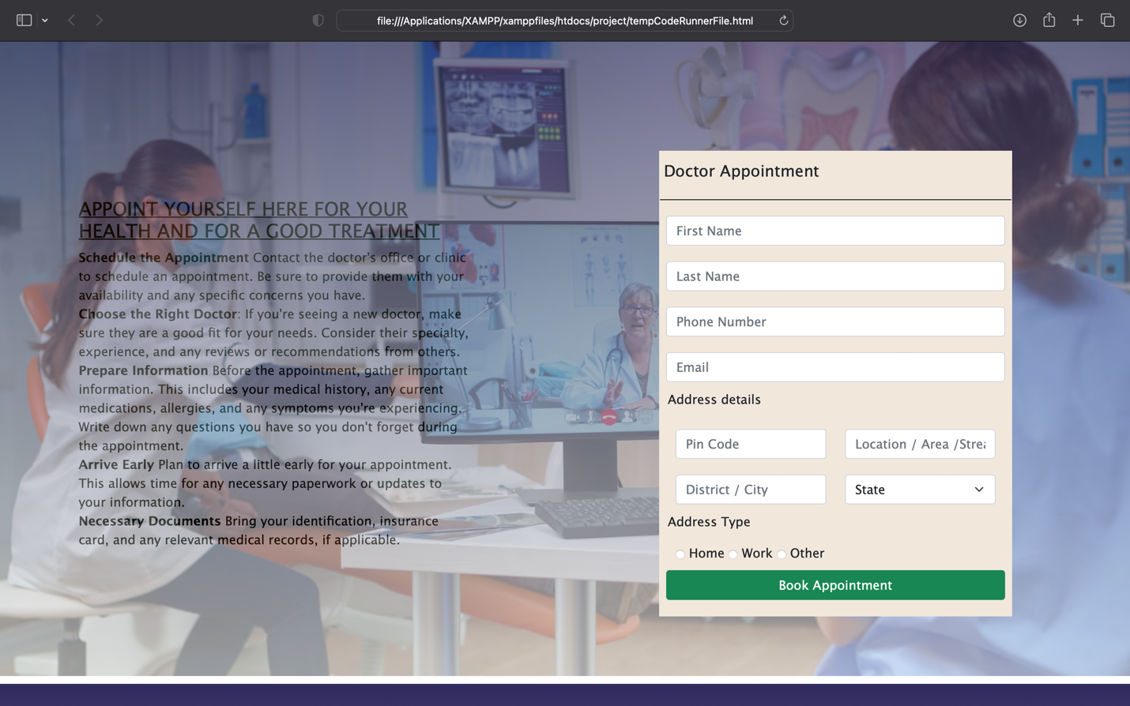

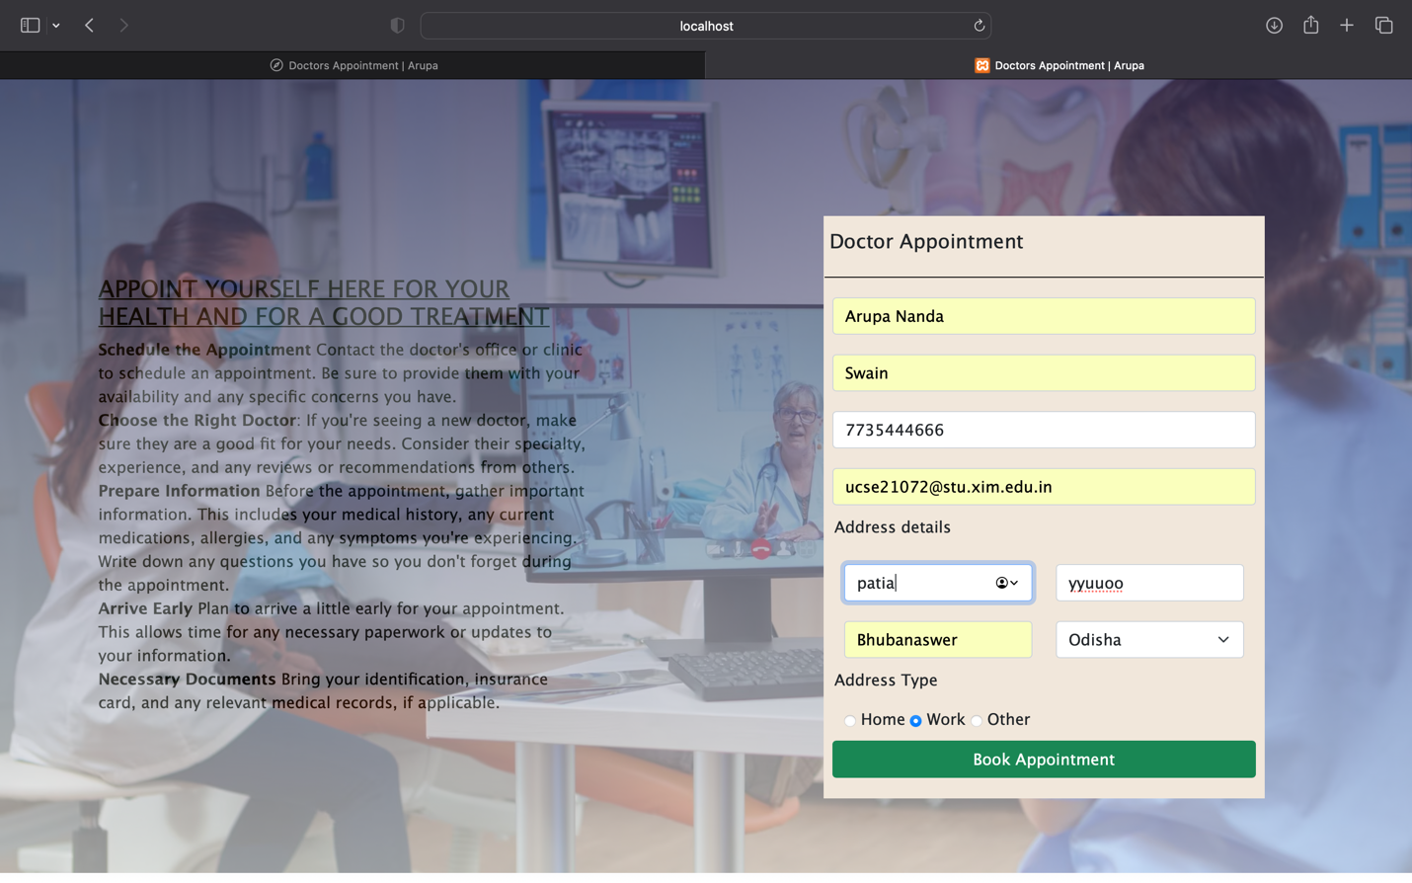

Alert to show that Appointment Booked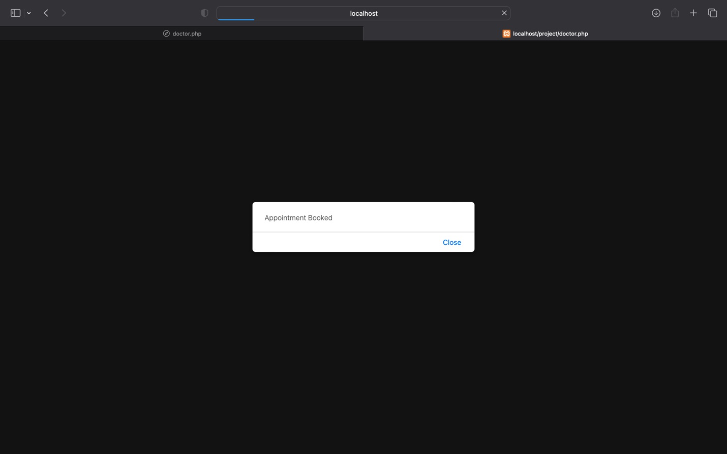

Data stored here:

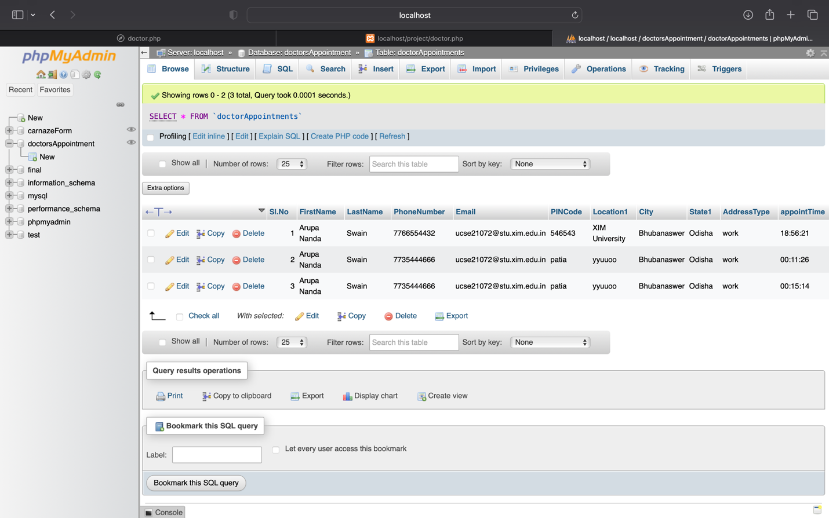

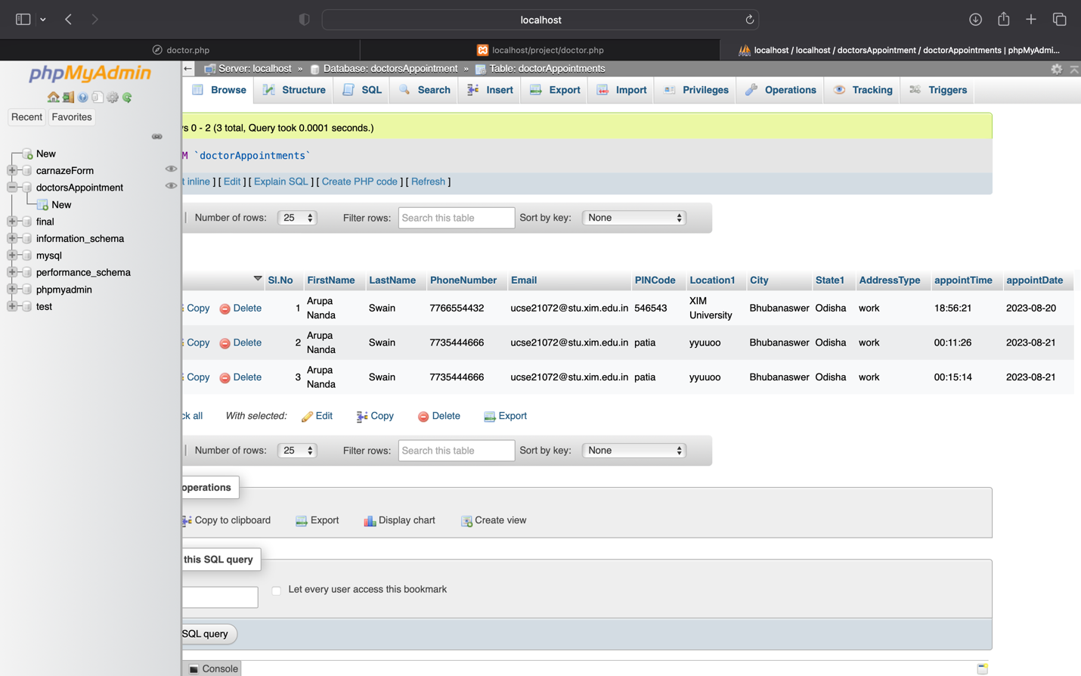

A easy Dashboard for Doctors to see the Appointments on the day

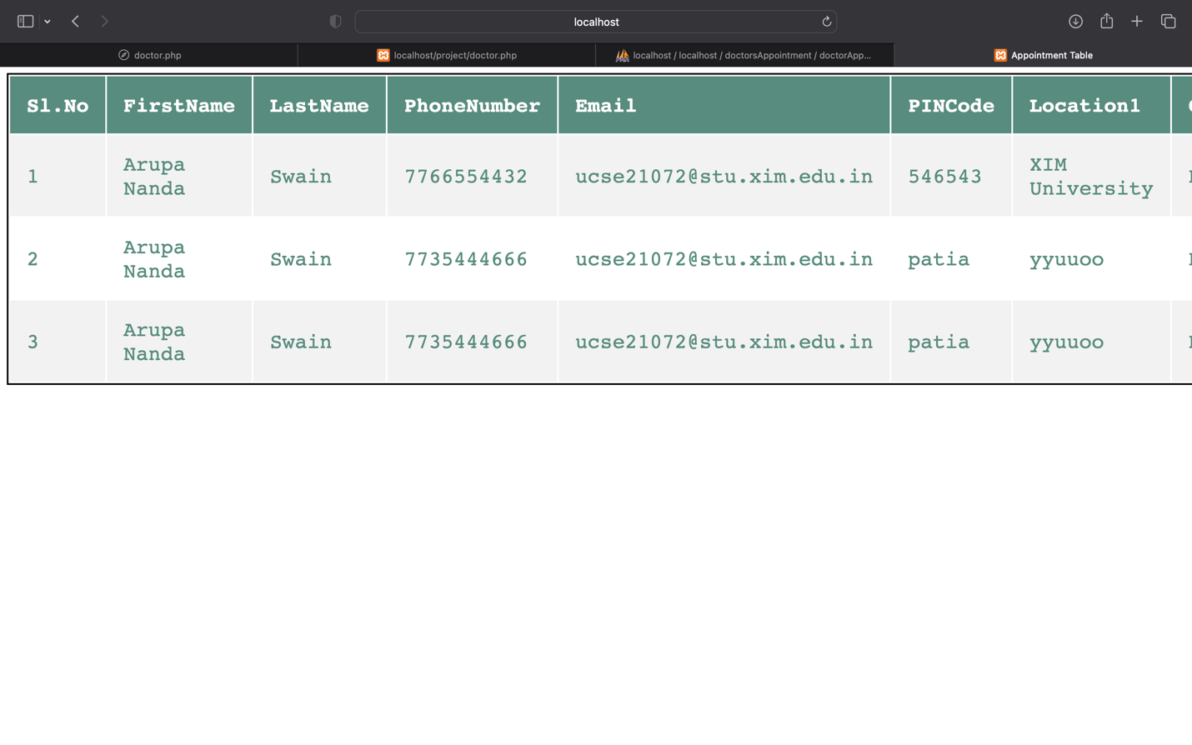

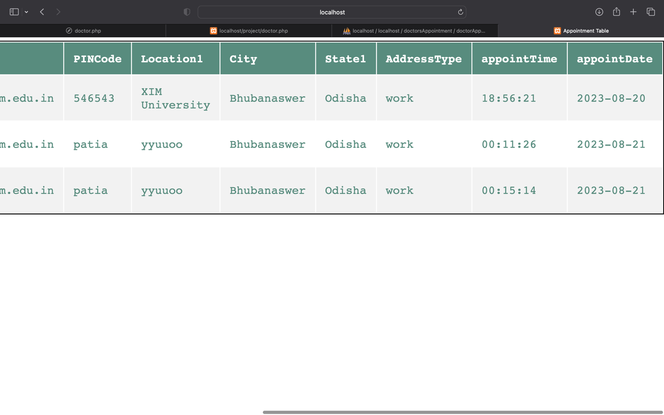

Name: ARUPA NANDA SWAIN

Roll No: UCSE21072

Student OF: XIM University